***Code Smells***

1. Illustrating code snippet:

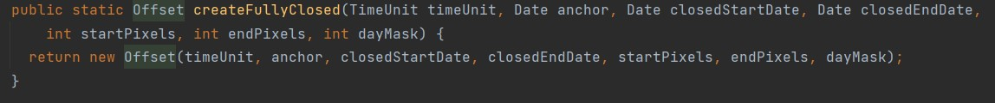

**Class location**: Ganttproject/biz.ganttproject.core/src/main/java/biz/ganttproject/core/chart/grid/Offset.java

**Code smell:** In the Offset.java class there is a method with an extensive parameter list in line 109, this increases the chance of something going wrong.

**Refactoring proposal:** The best solution would be to introduce parameter objects.

1. Illustrating code snippet:

**Class location**: ganttproject/biz.ganttproject.core/src/main/java/biz/ganttproject/core/chart/scene/gantt/DependencySceneBuilder.java

**Code smell:** The DependencySceneBuilder.java does not contain any comments regarding what the implemented functions do. Considering their size this could cause confusion to someone that is not familiar with the code.

**Refactoring proposal:** Add enough comments so that at least the purpose of the most extensive functions is clear.

1. Illustrating code snippet:

**Class location**: ganttproject/biz.ganttproject.impex.msproject2/src/main/java/biz/ganttproject/impex/msproject2/ProjectFileImporter.java

**Code smell:** The ProjectFileImporter.java is a very extensive class (733 lines), this means it contains a lot of responsabilities and would require a lot of comments to document it’s functionalities.

**Refactoring proposal:** The proper way to handle this is to divide the responsibilities into subclasses and hide the implementation from the large class.